In the name of God

Producer:

Mehrab Atighi

Subject:

Monte carlo method for Normal-Cuashy bayes estimator

Date:

2020/27/12

Supervisor:

Dr.Seyed Noorullah Mousavi

**Issue:**

For the normal-Cauchy Bayes estimator $$δ\left(x\right)=\frac{\int_{-∞}^{+∞}{\frac{θ}{1+ θ^{2}}e^{-\frac{{\left(x-θ\right)}^{2}}{2}}dθ }}{\int_{-∞}^{+∞}{\frac{1}{1+ θ^{2}}e^{-\frac{{\left(x-θ\right)}^{2}}{2}}dθ }}$$

solve the following questions when x = 0, 2, 4.  
a. Plot the integrands, and use Monte Carlo integration based on a Cauchy simulation to calculate the integrals.  
b. Monitor the convergence with the standard error of the estimate. Obtain three digits of accuracy with probability .95.  
c. Repeat the experiment with a Monte Carlo integration based on a normal simulation and compare both approaches.

**Solve:**

We know that according to the Monte carlo methods we have:

$$δ\left(x\right)=\frac{\int_{-∞}^{+∞}{\frac{θ}{1+ θ^{2}}e^{-\frac{{\left(x-θ\right)}^{2}}{2}}dθ }}{\int_{-∞}^{+∞}{\frac{1}{1+ θ^{2}}e^{-\frac{{\left(x-θ\right)}^{2}}{2}}dθ }}=\frac{π\int_{-∞}^{+∞}{\frac{1}{π}\frac{θ}{1+ θ^{2}}e^{-\frac{{\left(x-θ\right)}^{2}}{2}}dθ }}{π\int_{-∞}^{+∞}{\frac{1}{π}\frac{1}{1+ θ^{2}}e^{-\frac{{\left(x-θ\right)}^{2}}{2}}dθ }}$$

step1 :we set the $f(θ)$, the caushy normal distrubtion Caushu(0,1)

$$f\left(θ\right)=\frac{1}{π(1+θ^{2})}$$

step2 :we set the other functions infront of the integral,g(x)

so we have:

$$δ\left(x\right)=\frac{π\int_{-∞}^{+∞}{\frac{1}{π}\frac{1}{1+ θ^{2}}e^{-\frac{{\left(x-θ\right)}^{2}}{2}} θdθ }}{π\int_{-∞}^{+∞}{\frac{1}{π}\frac{1}{1+ θ^{2}}e^{-\frac{{\left(x-θ\right)}^{2}}{2}}dθ }}=\frac{π\int_{-∞}^{+∞}{f\left(θ\right)*e^{-\frac{{\left(x-θ\right)}^{2}}{2}} θdθ }}{π\int_{-∞}^{+∞}{f\left(θ\right)*e^{-\frac{{\left(x-θ\right)}^{2}}{2}}dθ }}$$

so now we set the $g_{1}\left(x,θ\right)=e^{-\frac{{\left(x-θ\right)}^{2}}{2}} θ ,g_{2}\left(x,θ\right)=e^{-\frac{{\left(x-θ\right)}^{2}}{2}}$

then:

$$δ\left(x\right)=\frac{π\int_{-∞}^{+∞}{f\left(θ\right)g_{1}\left(x,θ\right)dθ }}{π\int_{-∞}^{+∞}{f\left(θ\right)g_{2}\left(x,θ\right)dθ }}\underset{⇔}{M.c} \frac{πE_{f}\left[g_{1}\left(x,θ\right)\right]}{πE_{f}\left[g_{2}\left(x,θ\right)\right]} \underset{⇒}{}δ\left(x\right)=\frac{E_{f}\left[g_{1}\left(x,θ\right)\right]}{E_{f}\left[g_{2}\left(x,θ\right)\right]}$$

For $δ\left(x\right)$ we have:

> rm(list=ls())

> memory.limit(size=999999999)

[1] 1e+09

> x=c(0,2,4)

> N=10^5

> g1<-c();g2<-c()

> g.1<-c();g.2<-c()

> delta<-matrix(c(rep(0,3*N)),ncol = N)

> theta<-rcauchy(N)

> par(mfrow=c(1,3))

> for(i in 1:3){

+ f.1=function(theta){ theta/(1+(theta)^2)*exp(-(x[i]-theta)^2/2)}

+ f.2=function(theta){ 1/(1+(theta)^2)*exp(-(x[i]-theta)^2/2)}

+ plot(f.1,xlab="theta",ylab="functions",type ="l" ,xlim = c(-10,10),ylim=c(-1,1) ,col="blue" , sub=x[i])

+ plot(f.2,add=TRUE,type="l" , col="pink" , xlim = c(-10,10))}

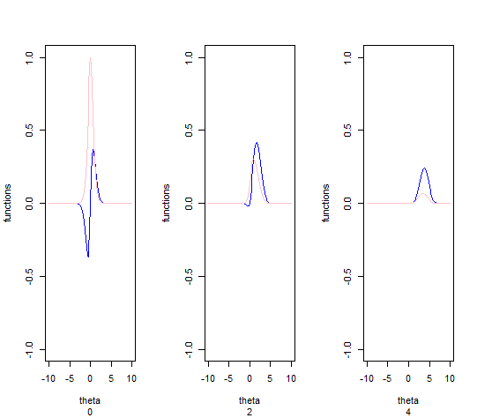

+ for(i in 1:N){

+ g1[i]<-theta[i]*exp(-(1/2*(x[j]-theta[i])^2))

+ g2[i]<-1*exp(-(1/2*(x[j]-theta[i])^2))

+ delta[j,i]<-mean(g1[1:i])/mean(g2[1:i])}

+ print(paste("the delta(x) value with x=",x[j],"is:",mean(g1)/mean(g2)))}

[1] "the delta(x) value with x= 0 is: -0.00233317554413187"

[1] "the delta(x) value with x= 2 is: 1.27888732761474"

[1] "the delta(x) value with x= 4 is: 3.42736175946439"

> o<-c()

> for(j in 1:3){

+ g.1<-function(t){(t/(1+(t^2)))*exp(-((1/2)*(x[j]-t)^2))}

+ g.2<-function(t){(1/(1+(t^2)))*exp(-((1/2)*(x[j]-t)^2))}

+ print(o[j]<-(integrate(g.1,-Inf,Inf)$val)/(integrate(g.2,-Inf,Inf)$val))}

[1] 0

[1] 1.282195

[1] 3.435062

> for(j in 1:3){

+ r<-which((delta[j,]=="NaN"))

+ for(w in 1:length(r)){

+ delta[j,r[w]]<-o[j]}}

> (sd<-apply(delta,1,sd))

[1] 0.01037757 0.01340714 0.02649938

> par(mfrow=c(1,3))

> for(j in 1:3){

+ q<-cumsum(delta[j,])/1:N

+ plot(q,type="l" ,sub = x[j],col=85*j,xlim=c(0,N),ylim=c(min(q),max(q)))

+ abline(h=o[j] ,col="black")}

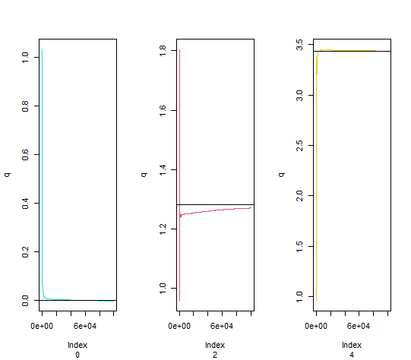

**Now we want to make it for normal:**

$$δ\left(x\right)=\frac{\int_{-∞}^{+∞}{\frac{θ}{1+ θ^{2}}e^{-\frac{{\left(x-θ\right)}^{2}}{2}}dθ }}{\int_{-∞}^{+∞}{\frac{1}{1+ θ^{2}}e^{-\frac{{\left(x-θ\right)}^{2}}{2}}dθ }}=\frac{\int_{-∞}^{+∞}{\frac{θ}{1+ θ^{2}}e^{-\frac{(x^{2}+θ^{2}-2xθ)}{2}}dθ }}{\int_{-∞}^{+∞}{\frac{1}{1+ θ^{2}}e^{-\frac{{(x}^{2}+θ^{2}-2xθ)}{2}}dθ }}$$

$$=\frac{\int_{-∞}^{+∞}{\frac{θ}{1+ θ^{2}}e^{-\frac{x^{2}}{2}}e^{-\frac{θ^{2}}{2}}e^{θx} dθ }}{\int_{-∞}^{+∞}{\frac{1}{1+ θ^{2}}e^{-\frac{x^{2}}{2}}e^{-\frac{θ^{2}}{2}}e^{θx} dθ }}=\frac{\int_{-∞}^{+∞}{\frac{θ}{1+ θ^{2}}e^{-\frac{x^{2}}{2}}e^{-\frac{θ^{2}}{2}}e^{θ}e^{x}dθ }}{\int_{-∞}^{+∞}{\frac{1}{1+ θ^{2}}e^{-\frac{x^{2}}{2}}e^{-\frac{θ^{2}}{2}}e^{θ}e^{x}dθ }}$$

= $\frac{\int_{-∞}^{+∞}{\frac{θ}{1+ θ^{2}}e^{-\frac{θ^{2}}{2}+θx}e^{-\frac{x^{2}}{2}}dθ }}{\int_{-∞}^{+∞}{\frac{1}{1+ θ^{2}}e^{-\frac{θ^{2}}{2}+θx}e^{-\frac{x^{2}}{2}}dθ }}$ = $\frac{\sqrt{2π}\int_{-∞}^{+∞}{\frac{θ}{1+ θ^{2}}e^{-\frac{θ^{2}}{2}+θx}*\frac{1}{\sqrt{2π} }e^{-\frac{x^{2}}{2}}dθ }}{\sqrt{2π}\int_{-∞}^{+∞}{\frac{1}{1+ θ^{2}}e^{-\frac{θ^{2}}{2}+θx}*\frac{1}{\sqrt{2π} }e^{-\frac{x^{2}}{2}}dθ }}$

Now if $if X\sim Normal\left(0,1\right),f_{X}\left(x\right)=\int_{-∞}^{∞}{\frac{1}{\sqrt{2π} }e^{-\frac{x^{2}}{2}}dx.}$

If we set $h_{1}\left(θ\right)=\frac{θ}{1+ θ^{2}}e^{-\frac{θ^{2}}{2}+θx}$, $h_{2}\left(θ\right)=\frac{1}{1+ θ^{2}}e^{-\frac{θ^{2}}{2}+θx}$

So We have :

$$δ\left(x\right)=\frac{\sqrt{2π}\int_{-∞}^{+∞}{h_{1}(θ)*f_{X}(x)dθ }}{\sqrt{2π}\int_{-∞}^{+∞}{h_{2}(θ)*f_{X}(x)dθ }}\underset{⇒}{M.C}δ\left(x\right)≅\frac{\sqrt{2π}E_{x}[h_{1}\left(θ\right)]}{\sqrt{2π}E_{x}[h_{2}\left(θ\right)]}=\frac{E_{x}[h_{1}\left(θ\right)]}{E_{x}[h_{2}\left(θ\right)]}$$

The two front function plot is same with cuashy plot.(so I don’t show it again.)

Now we want to estimate $δ\left(x\right)$,(according to up)with Normal-standard density function:

> #normal part:

> rm(list=ls())

> x=c(0,2,4)

> N=10^5

> h1<-c();h2<-c()

> h.1<-c();h.2<-c()

> delta2<-matrix(c(rep(0,3*N)),ncol = N)

> for(i in 1:3){

+ f.1=function(theta){ theta/(1+(theta)^2)*exp(-(x[i]-theta)^2/2)}

+ f.2=function(theta){ 1/(1+(theta)^2)*exp(-(x[i]-theta)^2/2)}

+ plot(f.1,xlab="theta",ylab="functions",type ="l" ,xlim = c(-10,10),ylim=c(-1,1) ,col=85 , sub=x[i])

+ plot(f.2,add=TRUE,type="l" , col="purple" , xlim = c(-10,10))}

> for( j in 1:3){theta<-rnorm(N,mean = 0,sd=1)

+ for(i in 1:N){

+ h1[i]<-(((theta[i])/(1+(theta[i])^2))*(exp((-1/2*(theta[i])^2)+(theta[i]*x[j]))))

+ h2[i]<-(((1)/(1+(theta[i])^2))*(exp((-1/2*(theta[i])^2)+(theta[i]*x[j]))))

+ delta2[j,i]<-mean(h1[1:i])/mean(h2[1:i])}

+ print(paste("the delta(x) value with x=",x[j],"is:",mean(h1)/mean(h2)))}

[1] "the delta(x) value with x= 0 is: 0.000377986859489263"

[1] "the delta(x) value with x= 2 is: 0.685799582291693"

[1] "the delta(x) value with x= 4 is: 1.58736740680525"

> o<-c()

> for(j in 1:3){

+ h.1<-function(t){(t/(1+(t^2)))*exp(-((1/2)*(x[j]-t)^2))}

+ h.2<-function(t){(1/(1+(t^2)))*exp(-((1/2)*(x[j]-t)^2))}

+ print(o[j]<-(integrate(h.1,-Inf,Inf)$val)/(integrate(h.2,-Inf,Inf)$val))}

[1] 0

[1] 1.282195

[1] 3.435062

> for(j in 1:3){

+ r<-which((delta2[j,]=="NaN"))

+ for(w in 1:length(r)){

+ delta2[j,r[w]]<-o[j]}}

> (sd<-apply(delta2,1,sd))

[1] 0.007764371 0.007211865 0.036078876

> par(mfrow=c(1,3))

> for(j in 1:3){

+ q<-cumsum(delta2[j,])/1:N

+ plot(q,type="l" ,sub = x[j],col=85*j,xlim=c(0,N),ylim=c(min(q),o[j]+1))

+ abline(h=o[j] ,col="black")}

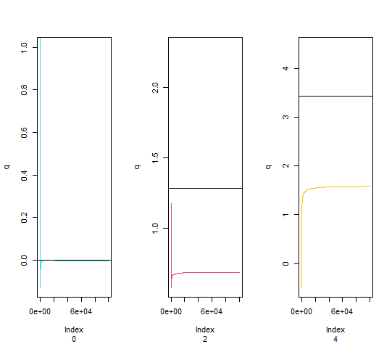

**Conclusion:** the estiamate for $δ\left(x\right)$ with normal-standard distrubtion is not good but the Caushy estimate is good for that,we can see that in estimate with cuashy random variable converges very quickly to $δ\left(x\right)$.